Ideation Phase
Brainstorm & Idea Prioritization Template

Date | 18February 2026
Team ID | LTVIP2026TMIDS83223
Project Name | Shopez-one stop shop for Online Products
Maximum Marks | 4 Marks

Brainstorm & Idea Prioritization Template:

Step-1: Team Gathering, Collaboration and Select the Problem Statement

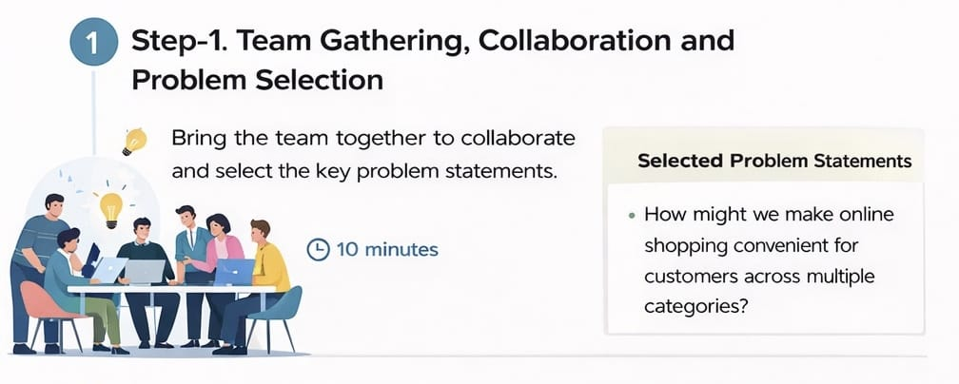

Step-2: Brainstorm, Idea Listing and Grouping
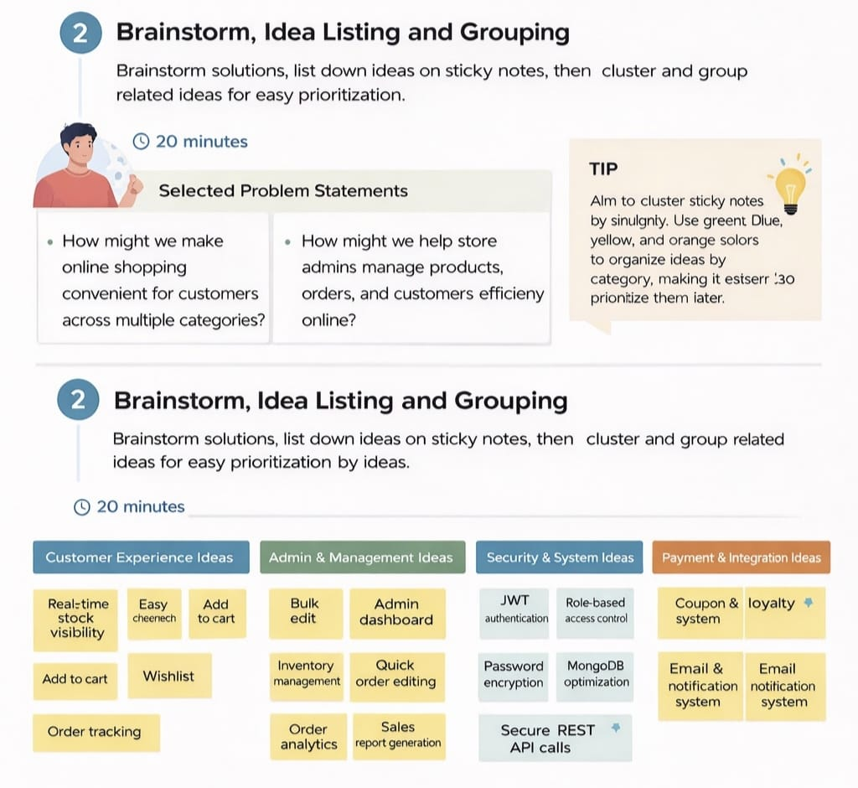

Step-3: Idea Prioritization
